**A/AN, PLURALS**

*We use* ***a/an*** *with singular nouns:*

*This is a table.*

*It’s an orange.*

*We use* ***a*** *with nouns beginning with a consonant, and we use* ***an*** *with nouns beginning with a vowel (a, e, i, o, u):*

*Give me an apple.*

*There is an elephant in the zoo.*

*It’s an amazing experience.*

*We also use* ***an*** *with nouns* ***beginning with h*** *if the h is not pronounced.*

*But we use* ***a*** *if the* ***h*** *is pronounced.*

*Give me an hour. (The* ***h*** *is not pronounced in* ***~~h~~our****.)*

*I want to buy a hat. (The* ***h*** *is pronounced in* ***hat****.)*

*We use* ***a*** *and* ***NOT an*** *with nouns* ***beginning with u*** *when it is pronounced /ju:/, like university:*

*Is there a university in this city?*

*I wear a uniform.*

***another*** *(=== an + other) is one word:*

*Can I have* ***another*** *cup of coffee?*

*We use* ***a/an*** *... when we say what a* ***thing or a person is****:*

*The sun is a star.*

*A mouse is an animal.*

*We use* ***a/an*** *... for* ***jobs*** *etc.:*

*I'm a dentist*

*Would you like to be a teacher?*

**Plurals in English**

**~~a tables~~**

*We* ***do NOT*** *use* ***a/an*** *with* ***plural*** *nouns:*

*These are tables. (NOT ~~a tables~~)*

*Regular plurals*

*We add* ***-s*** *to make plural nouns in English.*

*Sometimes we need to add* ***-es, -ies or –ves****.*

*Irregular plurals*

*Some words have irregular plurals and do NOT add -s to make their plural form.*

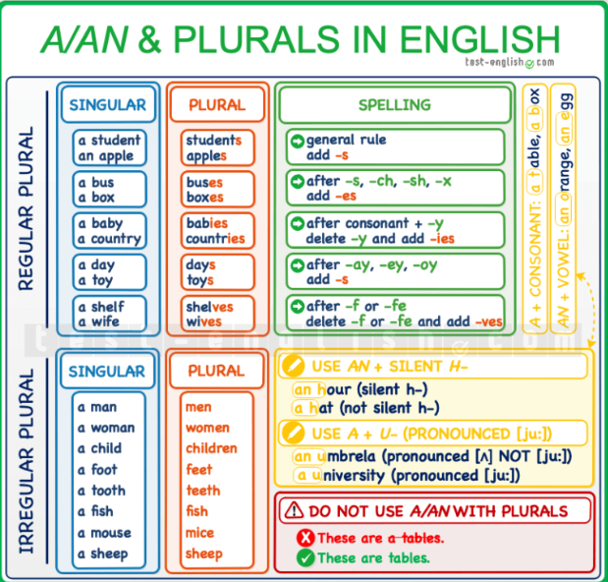

**A, SOME, ANY – COUNTABLE AND UNCOUNTABLE NOUNS**

***A noun can be countable or uncountable***

**COUNTABLE NOUNS**

***Countable nouns*** *are nouns that we can* ***count****: car, house, book, etc. We can say one car, two cars, three cars, etc.*

*Singular and plural*

*Countable nouns have* ***singular and plural*** *forms: a car/cars, a house/houses, a book/books, etc.*

*a/an + singular countable noun*

*We* ***CANNOT*** *use a singular countable noun* ***without*** *a determiner like* ***a/an*** *or* ***the****.*

*I have a car. (NOT ~~I have car~~.)*

*When I was a child. (NOT When ~~I was child~~.)*

**UNCOUNTABLE NOUNS**

***Uncountable*** *nouns are nouns that we* ***cannot******count****: money, milk, rain, etc. We cannot say ~~one money, two moneys,~~ etc.*

*Only singular*

***Uncountable*** *nouns do not have a plural form, they* ***only*** *have a* ***singular******form****: money/~~moneys~~, milk/~~milks~~, rain/~~rains~~, etc.*

*Not ~~a/an~~*

*We cannot use* ***a/an*** *+ uncountable noun.* ***A/an*** *means ‘one’, and we cannot count uncountable nouns.*

*I need money. (NOT ~~a money~~.)*

*We need to buy sugar. (NOT ~~a sugar~~.)*

***Types of words*** *that are uncountable*

*Some types of words that are typically uncountable are:*

***Food, drinks and liquids****: cheese, bread, pasta, coffee, milk, petrol, fuel, etc.*

***Materials****: iron, wood, metal, paper, plastic, etc.*

***Abstract******ideas and feelings****: information, advice, strength, time, love, excitement, etc.*

***Illnesses****: diabetes, alzheimer, cancer, etc.*

***Languages****: English, French, Spanish, etc.*

**COUNTABLE AND UNCOUNTABLE**

***Some nouns can be countable and uncountable*** *because they can refer to a unit or to ‘mass’ or ‘material’. Compare:*

*Yesterday I had two coffees. (=== two cups of coffee)*

*I love coffee. (=== the liquid that we drink)*

*I found one hair in my soup. (===one single hair)*

*She has beautiful hair. (=== the mass of hair on her head)*

**A/AN, SOME, ANY**

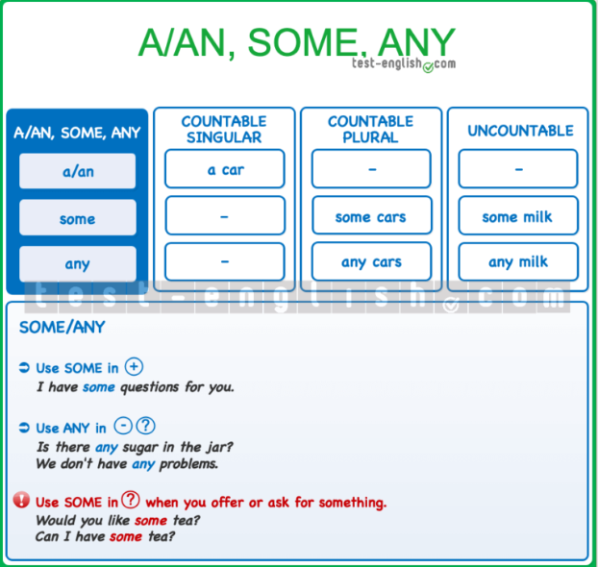***SUMMARY CHART***

**A/AN**

*We use* ***a/an*** *+* ***singular*** *countable noun.*

*I have a new car.*

*She has a brother and a sister.*

*We* ***cannot*** *use* ***a/an******before*** *a* ***plural*** *noun or an* ***uncountable*** *noun.*

*I need to buy sugar. (NOT ~~a sugar~~.)*

*We saw very beautiful places. (NOT ~~a very beautiful places~~.)*

**SOME/ANY**

*We use* ***some*** *and* ***any*** *before* ***countable plural nouns*** *or* ***singular uncountable nouns****.*

*He gave me some coins.*

*He didn’t give me any coins.*

*He gave me some money.*

*Some*

*We use* ***some*** *in* ***positive*** *sentences.*

*We cooked some cookies.*

*Any*

*We use* ***any*** *in* ***negative******sentences*** *and* ***questions****.*

*She didn’t send me any messages.*

*Have you got any brothers or sisters?*

***BUT*** *we use* ***some*** *in* ***questions*** *when we are* ***asking for something*** *or we are* ***offering something****.*

*Can I have some tea? (===I’m asking for some tea.)*

*Would you like some tea? (===I’m offering you some tea.)*

*You can't use a/an + uncountable nouns*

*But you can say* ***a piece of ... / a bottle of*** *... etc. + uncountable noun:*

*a bottle of water*

*a piece of cheese*

*a bowl of rice*

*a carton of milk*

*a bottle of perfume*

*a cup of coffee*

*a bar of chocolate*

*a piece of music*

*a game of tennis*